F1 Lap Time Prediction
  - Practice Challenge, Domain Understanding
Contents
Introduction 1
Project Overview 2
MoSCoW Analysis 2
Must-Have: 2
Should-Have: 3
Could-Have: 3
Won’t Have: 3
Possible Stakeholders 3
Primary Stakeholders 3
Academic Stakeholders 3
Research Question 3
Research Method 4
Literature Study, Library 4
Literature Findings and Comparison 4
Key Findings 4
Literature Comparison 5
Target Variable 5
Data Requirements 5
Conclusion 6
References 6
Domain Documents/Methods 6
Datasets 6

Introduction
Formula 1 is a racing sport in which small differences in laps can have an impact on race performance and strategy decisions. Driver’s laps are influenced by tyre degradation, weather conditions, fuel load, racetrack conditions, traffic, car performance and driver skill.
Being able to estimate a driver’s next lap is helpful to understand race pace and how different race conditions and moments affect overall performance. Due to this, it is obvious that lap times are not constant throughout the stage, which makes prediction difficult. Tyres degrade, weather changes, pilots appears on track and make it harder to be faster. Special events such as red flags (race stops), safety cars and virtual safety cars or pit stops affect lap times also, so a special attention needs to be taken for this events.
The purpose of this Practice Challenge is to investigate which factors affect the most lap times and figure out which data is required to build a Machine Learning Regression model capable of predicting a driver’s next lap time.

Project Overview
Item | Description
What | Predict a Formula 1 driver's next lap time in seconds.
Why | Understand which factors influence lap time and determine what data is required for reliable prediction.
How | Collect FastF1 data, preprocess race laps, create relevant features and compare regression models.
When | During the Practice Challenge, starting with domain research and data analysis, followed by modelling and evaluation.
Intended User | Someone analysing Formula 1 race pace, such as a race or performance analyst.

MoSCoW Analysis

Must-Have:
- Predict next lap time
- Include tyre, weather and previous lap time information
- Have clear evaluation metrics
- Clean invalid, pit, Safety Car, VSC laps
- Compare multiple models

Should-Have:
- Feature-importance
- Include driver information
- Ensure personal data is under GDPR legislation

Could-Have:
- Visualization of the prediction
- Frontend
- Test more advanced feature engineering
- MLP model

Won’t Have:
- Real time prediction
- 2026 data
- Strategy optimization
- Race Winner Prediction

Possible Stakeholders

Primary Stakeholders
Formula 1 analysts and teams, to understand race pace and variables that influence the most lap times.

Academic Stakeholders
Me, as I will improve my knowledge and research and teachers, as they are the evaluators of this performance.

Research Question
Which factors most influence Formula 1 lap times, and what data is required to build a reliable model for predicting a driver's next lap time?
This research question focuses on understanding race performance before modelling. The findings will be used to determine target variable, identify relevant features and decide how the data needs to be processed for the ML model.

Research Method

Literature Study, Library
Firstly, for my research, I used literature study from the DOT framework. Three academic papers were found through Google Scholar were analysed to get a better idea on lap time prediction.
In this papers, I looked into possible datasets, variables/features, target variables, limitations, results and performance of the model metric-wise.

Literature Findings and Comparison

Key Findings
Lap times tend to be affected by:
- Tyre degradation
- Fuel load
- Race conditions
- Special Events (Safety Cars, Yellow Flags)
The three first factors are the main ones I will be analysing, as special events are occasional and do not provide a realistic lap time for the model (it will be an outlier and create lousiness in the data).
The studies also show that FastF1 provides useful data, as it has lap times, tyre information, race conditions and telemetry. All of this will be considered into my dataset.

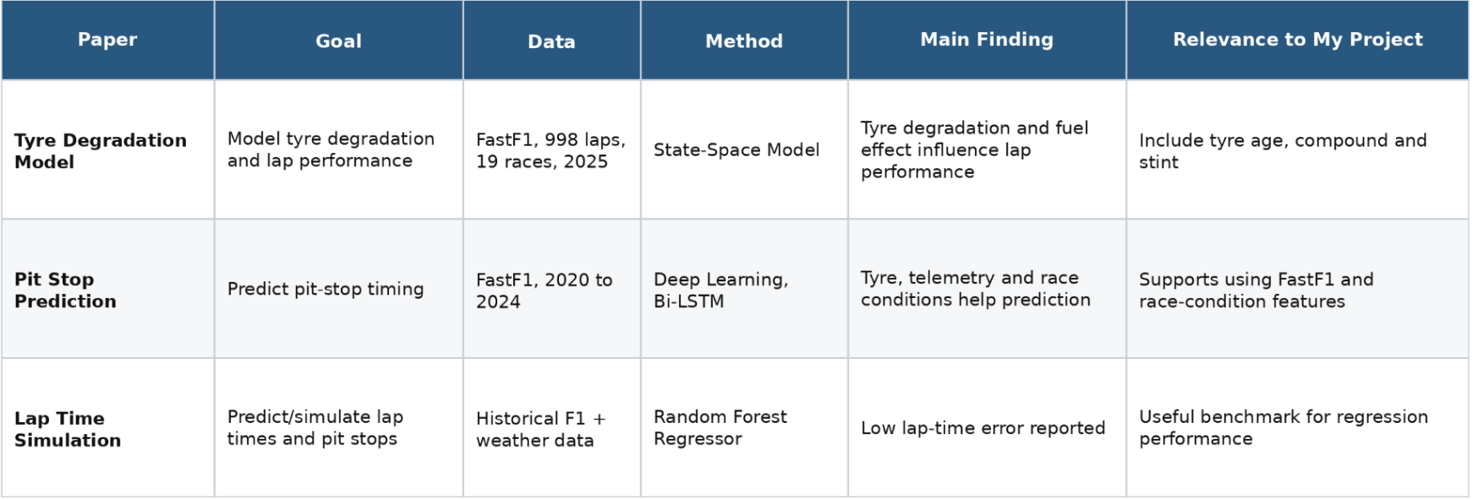
Literature Comparison

Target Variable
For this challenge the target variable will be driver’s next lap time, measured in seconds.
The model will use previous lap times, tyre degradations, weather conditions, fuel load, driver, car, team, circuit and stint to predict the next lap time.
Since lap times are numerical, I will need to use a regression model.

Data Requirements
FastF1 provides a lot of useful information for my model such as:
- Driver
- Team
- Circuit
- Lap number
- Previous lap time and averages
- Tyre compound
- Tyre age
- Stint
- Track temperature
- Rainfall
- Track status
The data also needs to meet some quality requirements. Pit laps, Safety Car laps, Virtual Safety Car laps and invalid laps need to be identified because they do not represent normal race pace. Information from the lap being predicted must not be used, to avoid data leakage.

Conclusion
This research to understand my domain was important to understand what I have to know before coding, understand limitations, possible datasets, comparisons between results and understand a bit more of the theory and make decisions on possible variables and target.
Based on this I will be predicting the next lap in seconds, using all the previous data possible and useful, still to be better analysed and determined, to then start gathering it and modelling.

References

Domain Documents/Methods
https://www.frontiersin.org/journals/artificial-intelligence/articles/10.3389/frai.2025.1673148/full - pit stops effect
https://www.scitepress.org/Papers/2025/146888/146888.pdf - main pdf for lap time prediction
https://journals.sagepub.com/doi/full/10.1177/22150218261446170 - tyre degradation

Datasets
https://www.kaggle.com/datasets/navenkumar1998/formula-1-dataset-with-weather-and-tyre-features/data
https://github.com/colecappello12/F1_SSM_Paper?

